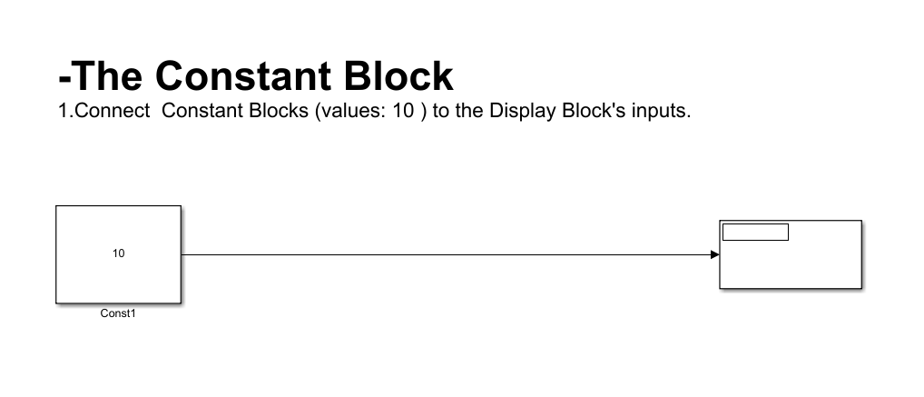

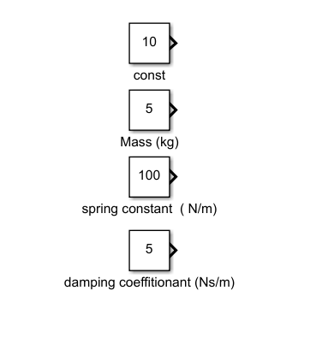**Notes:**

1-the Constant Block is used to generate a constant signal or value that can be used as an input in system.

2-example, a model of a spring-mass-damper system to simulate the response of an object to the constant force.

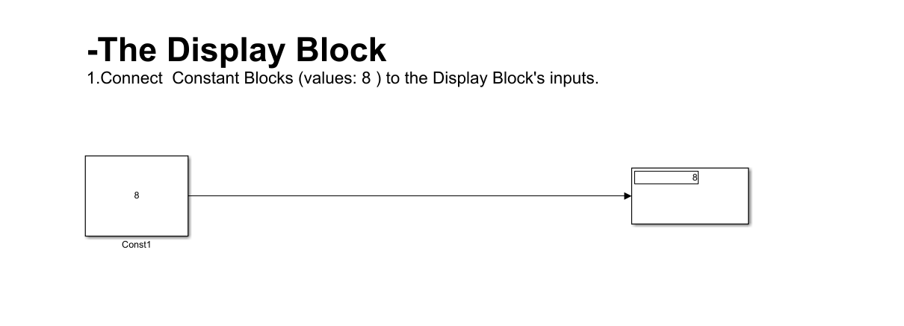

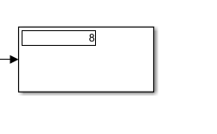**Notes:**

1-The Display block is to visualize or log data of interest during a simulation. You can use it to monitor variables, plot signals, or display information related to the behavior of your system.

2-example, a model of a spring-mass-damper system, and you want to display the position of the mass as it oscillates over time.

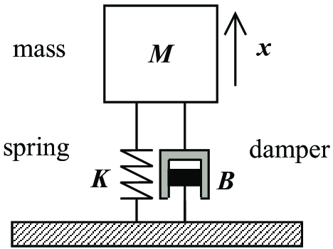

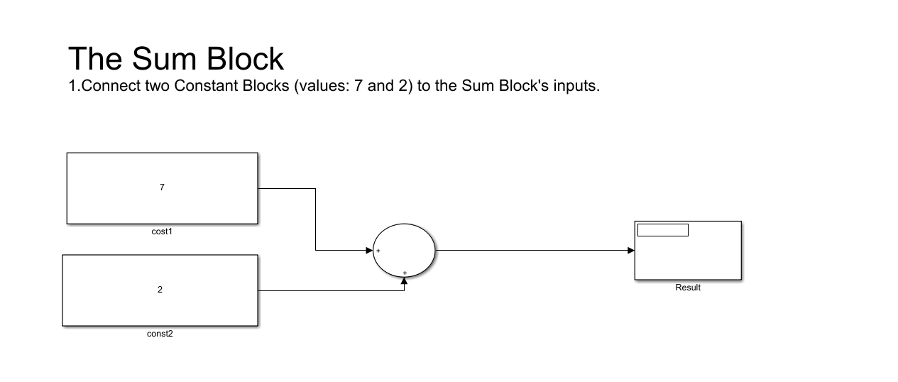

**Notes:**

1-The Sum Block is used to perform addition or subtraction operations on input signals within a Simulink model.

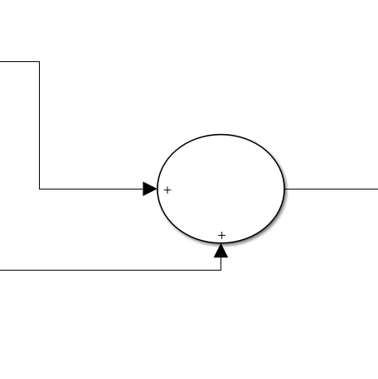2-Use Cases;

* Feedback Loops: Sum Blocks are used in control systems to feedback by comparing desired and actual outputs.
* Modeling Equations: Sum Blocks can use Sum Blocks to model equations by adding or subtracting terms to represent the behavior of systems.
* Signal Conditioning: Sum Blocks can use to condition signals before they are input into other blocks.

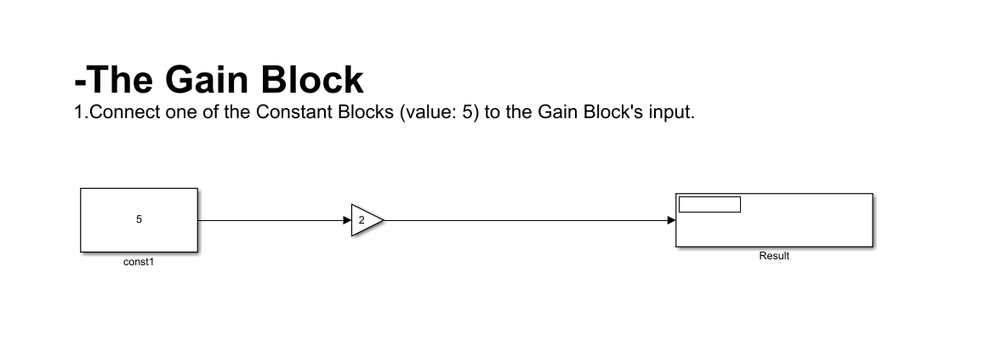

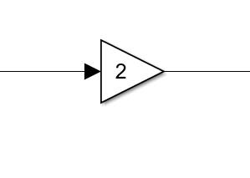**Notes:**

1. The Gain Block is used to perform a multiplication operation on an input signal by applying a constant factor, allows to adjust the magnitude or amplitude of the signal.
2. example, coefficient of PID Control.

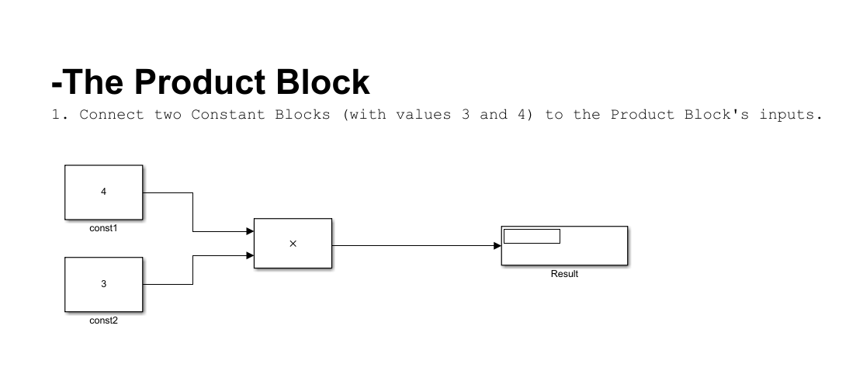

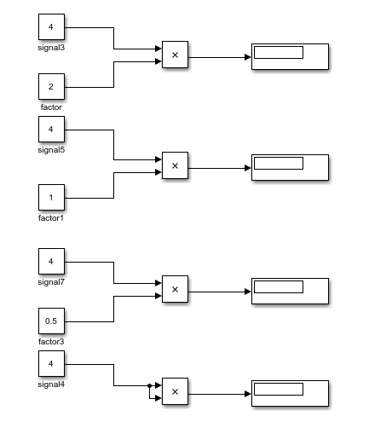**Notes:**

1. The Product Block is used to perform multiplication operations on input signals. allows to multiply two or more input signals to produce an output signal.
2. Use Cases: example, Scalar Multiplication signals.